

**Philip Boyle G00325728**

Final Year Project Design Document

**Table of Contents:**

1. Introduction
2. Design
3. System Requirements
4. Technologies Used
5. Development Process
6. Conclusion

**Introduction**

For my Final Year Project I decided that I wanted to design and build a classic card game. At first I wanted to make the traditional Irish game of “Twenty Five” but, due to the complicated (and argument inciting) rules of the game I decided to go with the more user friendly game of “Pairs”.   
  
Pairs is a memory game in which the player deals out the deck of cards face down on the table and proceeds to flip them 2 at a time to try and find the matches or “pairs” of each. The pairs are defined by the value on the card, the suit is not a factor, so “2 of Hearts” can be paired to “2 of Clubs”. As you will not get a pair on every flip of the cards, you have to begin memorising the location and values of the cards you have flipped so that when you find a card with value you recognise you can find its pair easy. The game can be challenging at first but once you get the hang of it becomes very fun and a very good memory exercise.

**Design**

I began my design process by playing the card game physically while noting any ideas for the design and logic that I thought of while playing. This proved very useful in helping me picture the final product in my head along the development process.   
  
I chose to limit the deck size to 26 cards in my game, meaning there will only be 13 pairs, I chose to do this because while playing the card game myself with the whole deck, I found it a bit long winded whereas with 26 cards, the game rarely lasts more than 2 minutes, which made it a perfect time passer.

I wanted to make the game feel authentic and traditional so when choosing my art assets I intentionally chose simple pieces that most people would find familiar. I decided on a red felt texture for the table top and chose a simple green card-back very similar to one I have in real life.

I decided to keep the User Interface simple, needing only 2 buttons on the Home Screen “Play” and “Quit”. “Play” opening the game screen and “Quit” closing the application. In the game screen there is a “Pairs Remaining” counter which lets the player know how many pairs are left, as well as a “Restart” and a “Give Up” button. When the game is finished, the player is brought to a “Win” screen where they can either replay the game or quit to the menu.

**System Requirements**

The game is designed and built for PC, Mac and Linux.  
A mouse/touchpad is required to play the game.

There are no specific system requirements to play the game, it is not a very large game and should run on every modern computer.

The game lets you chose your resolution and the graphics quality before playing so it will adapt to your computer’s needs.

**Technologies Used**

For this project I decided to use Unity3d and write the application in C#.   
  
I used Unity because it is widely recognised as a brilliant development tool and has a large and very helpful online community which I kept in mind in case I ran into any project-killing problems.  
  
I decided on using C# because it was the language I was the most familiar with when it came to game development and the one I was most confident and comfortable using.

**Development Process**

I began the development process by creating a new project in Unity. I then found, selected and added my art assets (I found them on “opengameart.org”). I then create my first scene, the “Main Menu” this is the first screen the player will see when they open the game. I added a title “Welcome to PB Pairs” and 2 buttons “Play” and “Quit”. I then wrote the C# script for the Menu, it controls what happens when the buttons are pressed. So when “Play” is pressed it launches the game and when “Quit” is pressed it closes the application.  
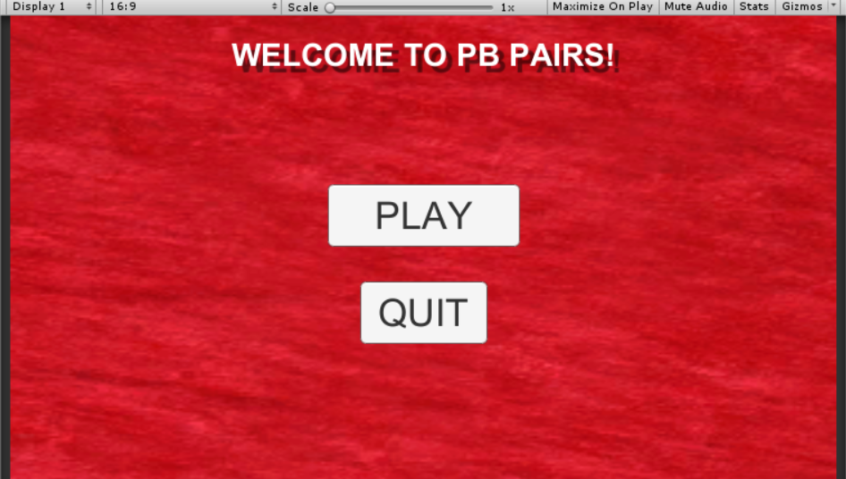

Next I created my “Game” scene. This is where most of my work began. I gave the scene a title “Find the pairs!” and added text to the bottom of the screen “Pairs Remaining: 13” the counter has a default text of 13 but will be changed by the “Pairs” script later. I added the 26 facedown cards and gave them all the “Button” component.

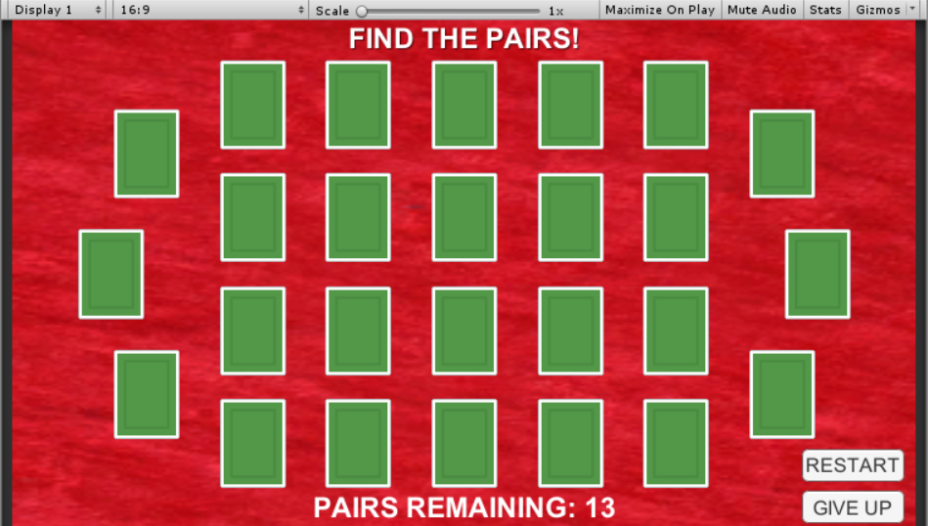

I then proceeded to write the C# script for the cards. I named the script “Card” it handles the cards behaviour, handles giving them the correct Face Art and things like that.

I then wrote the main script for the game called “Pairs” this is where most of my code is. This script took me a long time to figure out how to write as it contained most of the logic for the game, it sets the cards up with a value “1 – 13” it does this twice ensuring that there is a pair for each card.   
  
I hit a major problem in the writing of this script which resulted in Unity crashing every time I ran the game. Thanks to the help of the incredible community on the website (“stackoverflow.com”) I was eventually able to piece together what was causing the problem. It was an infinite While loop. I managed to fix this and was able to move on to finishing the game.

Once this script was done, the game was pretty much finished all that was left was the polishing of it. I added a “Restart” and “Give Up” button for the user, as well as a “Win” scene, the game just quit to desktop previously. The Win scene is shown below: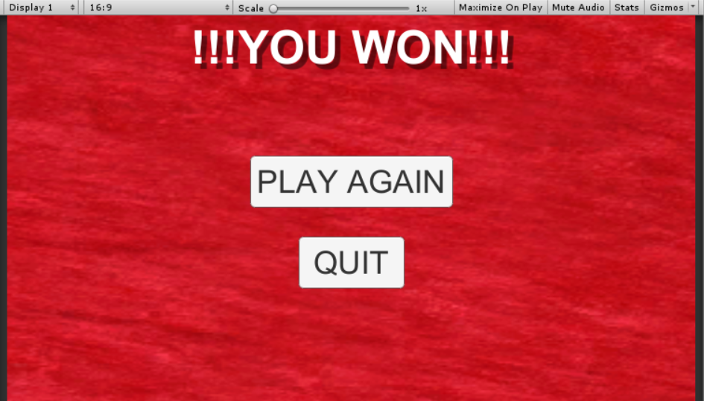

**Conclusion**

Overall I am very happy with the way the project turned out. The finished game looks exactly like what I had pictured in my head before setting out on the development process.  
The development process went relatively smoothly except for the stressful few hours hunting that one infinite while loop. The logic behind the game tested my programming skills very well and I had a very fun time thinking about the best way to create the game.

If I were to revisit the project in the future, I would very much like to add sound effects and background music as the game feels a bit rudimental without them.   
I would also like to port the game to Android so that it will be more accessible to my friends and family.

For now though, I am quite happy playing it on my laptop when I find myself with nothing to do.

Thank you for reading and I hope you enjoy the game,   
  
Philip